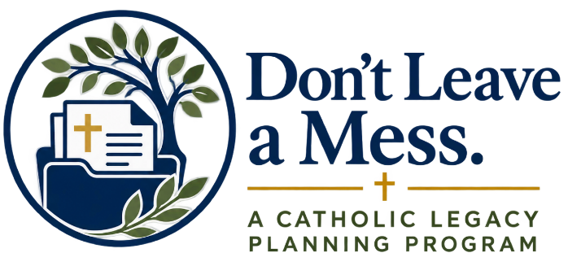

Reflection Guide
What Do I Want My Legacy to Be?
Before making plans, completing documents, or sharing your wishes with others, take some time to consider what matters most to you. This guide is designed to help you reflect prayerfully on your life, the people you love, the gifts God has entrusted to you, and the legacy you hope to leave.
You do not need to have all the answers. Simply begin.

Begin in Prayer
Find a quiet place and take a few moments to place yourself in the presence of God.
You may begin with this prayer:
Heavenly Father,
Everything I have and everything I am is a gift from You. Thank You for the people You have placed in my life, for the faith You have given me, and for the many blessings You have entrusted to my care.
Give me wisdom as I reflect on my life and my responsibilities. Help me to recognize what matters most, to consider how I can care well for those I love, and to understand the legacy of faith, love, and generosity You are calling me to leave.
Guide my thoughts and give me peace as I place my life and my future in Your hands.
Amen.

1. What Matters Most to Me?
Jesus reminds us:
“For where your treasure is, there will your heart be also.” — Matthew 6:21
Think about your life as a whole. Consider the people, experiences, beliefs, and commitments that have shaped you.
Reflect:
Who are the most important people in my life?
What relationships am I most grateful for?
What values have guided the way I have tried to live?
What role has my Catholic faith played in my life?
What am I most grateful God has given me?
When I think about the life I have lived so far, what am I most proud of?
What do I hope the people closest to me understand about what has mattered most to me?
What matters most to me?

2. Who Has God Entrusted to My Care?
Our responsibilities are one of the ways we live out our love for others.
Think about the people who depend upon you now or who may need to be considered in the future.
Reflect:
Who depends on me financially, emotionally, or practically?
Is there a spouse, child, grandchild, parent, sibling, or other loved one whose needs I especially want to consider?
Are there children or adults with special circumstances for whom I feel a particular responsibility?
Are there people outside my immediate family whom I would want to care for?
If I were no longer able to fulfill my current responsibilities, what would I hope would happen?
The people I especially want to care for are:

The responsibilities I would want to make sure are handled are:

3. If I Could Not Speak for Myself
The Church teaches that every human person possesses dignity throughout every stage of life. Our Catholic faith should help shape the way we think about serious illness, medical treatment, suffering, and care at the end of life.
Reflect on what matters to you.
If I became seriously ill and could not make decisions for myself, whom would I trust to act on my behalf?
What qualities would I want that person to have?
Would I want my Catholic faith to guide the medical decisions made for me?
What would I want someone making those decisions to understand about my beliefs and values?
What does receiving compassionate and dignified care mean to me?
Are there questions about Catholic teaching on medical care that I would like to understand better?
If someone had to make decisions for me, I would want that person to understand:

4. My Catholic Faith and the End of Life
Saint Paul reminds us that our hope is ultimately in Christ:
“Whether we live, therefore, or die, we are the Lord’s.” — Romans 14:8
Our Catholic faith accompanies us throughout life and continues to guide the Church’s care for us at the end of our earthly journey.
Reflect:
What does my Catholic faith mean to me as I think about the end of my earthly life?
What role would I want prayer and the sacraments to have if I became seriously ill?
Would I want a priest to be contacted?
What would I want my family to understand about my faith in the resurrection and eternal life?
What spiritual practices, devotions, saints, or prayers have been especially meaningful to me?
The parts of my faith I especially hope my family understands are:

5. My Funeral and Burial
A Catholic funeral is an act of faith in Jesus Christ and the resurrection. It is also an opportunity for the Church to pray for the deceased and support those who mourn.
Imagine your own funeral many years from now.
Reflect:
What would I want my funeral to express about my Catholic faith?
Is having a Catholic funeral Mass important to me?
Where would I hope my funeral would be celebrated?
Have particular Scripture passages, hymns, saints, or prayers been especially meaningful during my life?
Have I thought about burial or another final resting place?
What would I hope my children, grandchildren, family, and friends take away from the celebration of my funeral?
When I think about my funeral, what matters most to me is:

6. What Has God Entrusted to Me?
Over a lifetime, we accumulate many things. Some have financial value. Others have value because of the memories and stories attached to them.
Think broadly about what you have been given and what you have built.
This might include:
A home or other property
Savings and financial accounts
Retirement accounts
Insurance
Vehicles
Personal belongings
Jewelry or family heirlooms
Photographs and family records
Religious objects
Digital accounts or information
Items with special sentimental value
Reflect:
What possessions are especially important to me?
Are there items that carry an important family story?
Are there particular things I already know I would want someone to receive?
Are there possessions that might require explanation because their meaning would not be obvious to someone else?
What have I accumulated that another person would eventually need to sort through?
The things that have particular meaning to me include:

7. What Do I Want My Resources to Accomplish?
Scripture reminds us that we are stewards of what God has placed in our hands.
Consider what you would hope your resources accomplish after your earthly life is complete.
Reflect:
Who would I want to provide for first?
Are there particular needs within my family I would want to address?
What organizations or causes have mattered deeply to me?
Has my Catholic parish been an important part of my life or my family’s life?
Are there Catholic ministries, schools, charities, or other works I would want to support?
Could part of my legacy continue the generosity I have practiced during my lifetime?
The people and causes I would want my resources to care for include:

8. The Legacy That Cannot Be Measured in Money
Your legacy is much larger than what you own.
Think about someone whose life has had a lasting influence on you. What do you remember about that person?
Chances are, you remember how that person lived.
Now consider your own life.
What do I hope my children or grandchildren remember about me?
What do I hope they remember about my faith?
What lessons do I hope my life has taught?
What traditions would I like to see continue?
What qualities do I hope people associate with the way I lived?
Where have I seen God at work in my life?
What story of faith would I want future generations of my family to know?
I hope the people who love me remember that I:

I hope my Catholic faith is remembered through:

9. What Still Needs My Attention?
As you worked through these questions, you may have noticed areas you have never considered before.
That is part of the purpose of this reflection.
Without trying to solve anything today, simply identify the areas that deserve more attention.
Check any that apply:
☐ Caring for family or dependents
☐ Medical wishes
☐ Who should make decisions for me if I cannot
☐ Catholic teaching regarding medical and end-of-life care
☐ Funeral wishes
☐ Burial wishes
☐ Important personal or financial information
☐ Personal possessions or family heirlooms
☐ Providing for family
☐ Charitable or parish giving
☐ My spiritual legacy
☐ Something else: ___________________________________________

10. My Legacy
Now bring everything together.
Imagine that many years from now, someone who loves you is describing the life you lived.
What do you hope they say?
What do you hope your life has taught them?
What do you hope continues because you were here?
Complete this sentence:
The legacy I hope to leave is…

