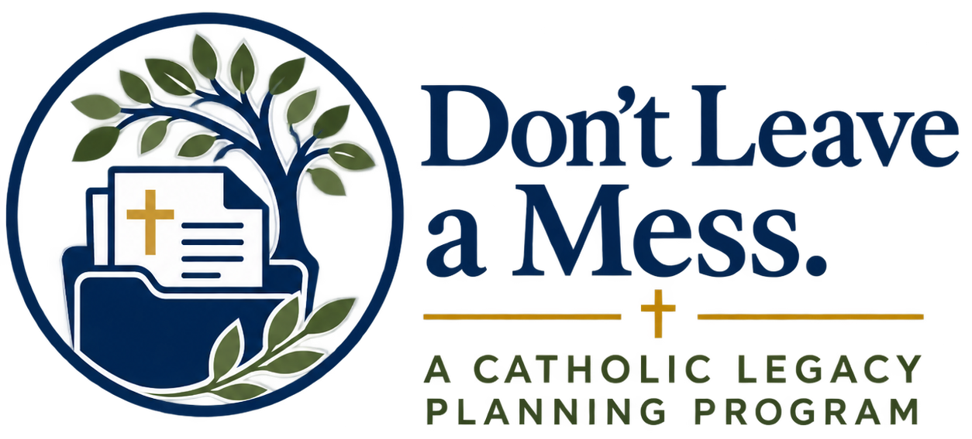
SHARING YOUR PLANS
A Conversation Guide
A good plan should not be a secret.
You have taken time to reflect, make decisions, and put important information in order. The next step is to make sure the people who may someday need your plans know that they exist, understand their role, and know where to find what they need.

How to use this guide
You do not need to share every detail with everyone. Use the five sections that follow to decide what each person needs to know. You can have these conversations one at a time, revisit them when plans change, and use the checkboxes to keep track of what you have shared.
Before you begin
□ Know where your important documents are kept and how the appropriate person can access them.
□ Make sure the people you have named for important roles are willing to serve.
□ Focus on the information the person may actually need; you do not need to discuss every financial or personal detail.
□ If a conversation is difficult, start with one simple reason: “I want to make things easier for the people I care about.”
□ Revisit these conversations after major life changes or when you update your documents.
One important principle
The goal is not to predict every future situation. The goal is to make sure the right people know your wishes, know their responsibilities, and know where important information can be found.

1 | Your Family  Help the people closest to you understand the big picture.

Person I plan to talk with: ________________________ | Date / target date: ________________________

Why this conversation matters
Family members are often the first people called in a crisis and the people most affected after a death. A clear conversation now can reduce uncertainty later and help everyone understand the decisions you have already made.

What to talk about
□ Tell them that you have put important plans and documents in place.
□ Share the general wishes that matter most to you, especially anything you would want the family to understand together.
□ Explain who you have chosen for key roles, such as your executor and health care decision-maker.
□ Tell them where your important documents and planning information are kept.
□ Talk about your Catholic faith, sacramental wishes, and funeral preferences if those are important to you.
□ Let them know whether there are any people, responsibilities, pets, property, or traditions you especially want remembered or cared for.
□ Explain that some decisions may be handled by the people you have legally named, even when other family members are involved.
You do not have to disclose everything
A family conversation can stay at the “big picture” level. Account balances, passwords, detailed gifts, and other private information usually do not need to be shared with everyone.

A simple way to begin
“I’ve been putting a few things in order so that, if something happens to me, no one has to guess. I want you to know the big picture and where my plans are kept.”

Notes / follow-up:
________________________________________________________________________________
________________________________________________________________________________

2 | Your Executor or Personal Representative  Make sure the person carrying out your estate plan is prepared.

Person I plan to talk with: ________________________ | Date / target date: ________________________

Why this conversation matters
Your executor or personal representative may be responsible for important practical and legal tasks after your death. They should know that you have chosen them, be willing to serve, and know how to locate the documents and people they may need.

What to talk about
□ Tell the person that you have named them as executor or personal representative and confirm that they are willing to serve.
□ Tell them where the original will and related estate documents are kept and how they can be accessed when needed.
□ Provide the name and contact information of the attorney or other professional who helped with your planning, if applicable.
□ Tell them where they can find a current list of important accounts, property, insurance, debts, and recurring obligations.
□ Make them aware of any specific personal property, family circumstances, or responsibilities that may need special attention.
□ Tell them about funeral planning information and the people who should be contacted promptly.
□ Let them know if charitable or parish gifts are included in your plans and where those instructions can be found.
Keep access practical and secure
Your executor should know where information is located and how to obtain it when appropriate. You do not need to hand over sensitive passwords or financial details during this conversation.

A simple way to begin
“I’ve named you as the person I would like to handle my estate. I want to make sure you’re comfortable with that role and know where to find the documents and information you would need.”

Notes / follow-up:
________________________________________________________________________________
________________________________________________________________________________

3 | Your Health Care Decision-Maker  Help the person who may speak for you understand your wishes and values.

Person I plan to talk with: ________________________ | Date / target date: ________________________

Why this conversation matters
If you are unable to make or communicate your own medical decisions, the person you have chosen may be asked to speak on your behalf. A document is important, but a conversation gives that person context for the choices you would want made.

What to talk about
□ Tell the person that you have chosen them to serve as your health care decision-maker and confirm that they are willing to serve.
□ Give them a copy of your advance directive or tell them exactly where it can be found.
□ Discuss the values and priorities that should guide decisions if the document does not address a specific situation.
□ Explain any Catholic beliefs or moral concerns you want respected in your medical care.
□ Share your preferences about spiritual care, including contacting a priest and receiving the sacraments when appropriate.
□ Tell them where your emergency medical information, medication list, physician contacts, and insurance information are kept.
□ Make sure close family members know who has been chosen to make decisions if you cannot speak for yourself.
The conversation matters as much as the form
No document can describe every possible medical situation. Your decision-maker will be better prepared if they understand the values, faith, and priorities that should guide difficult choices.

A simple way to begin
“If I ever couldn’t speak for myself, I would want you to help make medical decisions for me. I want to talk through what matters to me so you would not have to guess.”

Notes / follow-up:
________________________________________________________________________________
________________________________________________________________________________

4 | Your Financial Power of Attorney  Give the person who may help with finances enough information to step in.

Person I plan to talk with: ________________________ | Date / target date: ________________________

Why this conversation matters
If you have authorized someone to handle financial matters for you, that person may need to act while you are living but unable to manage things yourself. They should understand the role, know where the document is kept, and know how to locate essential financial information.

What to talk about
□ Tell the person that you have named them in your financial power of attorney and confirm that they are willing to serve.
□ Explain where the power of attorney document is kept and how it can be accessed if it is needed.
□ Tell them where to find a current list of banks, investments, retirement accounts, insurance, property, debts, and regular bills.
□ Identify important professional contacts, such as your financial adviser, accountant, attorney, insurance agent, or benefits office, if applicable.
□ Explain any ongoing responsibilities they may need to manage, such as housing costs, charitable giving, care expenses, or support for another person.
□ Discuss how you keep digital financial information secure and how the appropriate person could obtain needed access.
□ Let them know that beneficiary designations are generally maintained directly with the institution holding the account and may be separate from your will.
Do not create an unnecessary security risk
The goal is to make information findable, not to spread passwords or sensitive account details. Use a secure method for storing access information and tell the appropriate person how it can be obtained if needed.

A simple way to begin
“I’ve named you to help handle financial matters if I’m ever unable to do that myself. I want to show you where the important information is and make sure you understand what I would be asking you to do.”

Notes / follow-up:
________________________________________________________________________________
________________________________________________________________________________

5 | Your Pastor or Parish Staff  Make your faith, funeral, and parish wishes easier to honor.

Person I plan to talk with: ________________________ | Date / target date: ________________________

Why this conversation matters
Your parish may be an important part of your spiritual care, funeral planning, and legacy. Sharing key information can help your family know whom to contact and can help the parish understand wishes that are especially important to you.

What to talk about
□ Let the appropriate parish contact know if you have specific Catholic funeral or liturgical wishes you would like your family to follow.
□ Tell your family which parish and priest you would want contacted in the event of serious illness or death.
□ Make your wishes for the sacraments and spiritual care known to your family and health care decision-maker.
□ If you have completed a Catholic funeral planning worksheet, tell your family where it is kept and consider sharing a copy with the parish if appropriate.
□ If your estate plan includes a gift to your parish, the Archdiocese, or another Catholic ministry, make sure the organization is identified clearly in your documents.
□ If a planned gift has a specific purpose, consider discussing it with the parish or ministry so that your intention is understood and can be carried out appropriately.
□ Keep parish contact information with your other important planning information.
A parish conversation can be simple
You may only need to confirm funeral or sacramental wishes, identify the right parish contact, or discuss a planned charitable gift. Share only what is relevant to the parish’s role.

A simple way to begin
“I’m putting my plans in order, and my Catholic faith is part of those plans. I want to make sure my family and parish understand the wishes that are most important to me.”

Notes / follow-up:
________________________________________________________________________________
________________________________________________________________________________

MY SHARING PLAN
Use this page to keep track of the conversations you still need to have.
Conversation | Person | Target Date | Completed
Family |  |  | □
Executor / Personal Representative |  |  | □
Health Care Decision-Maker |  |  | □
Financial Power of Attorney |  |  | □
Pastor / Parish Staff |  |  | □
One place everyone should know about
Where are your important planning documents and information kept?
________________________________________________________________________________
________________________________________________________________________________
________________________________________________________________________________
________________________________________________________________________________
Review your conversations when your plans change
A move, marriage, death in the family, new diagnosis, major financial change, or update to your legal documents may be a reason to revisit one or more of these conversations. A short update can prevent old information from becoming the source of confusion later.

Important note: This guide is for educational and planning purposes and is not legal, financial, tax, or medical advice. Your circumstances may require guidance from an attorney, financial professional, health care professional, or other qualified adviser.

